

Spittal Primary School
Nursery Class



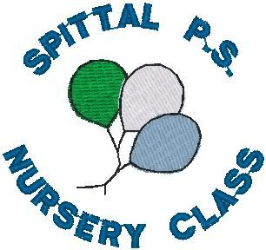

Handbook


Session 2026/2027
0141 634 9349

Contents Page
- Staffing………………………………………………………………………………. 3
- Nursery Opening Hours.......................................................4
- Holidays for session 2026/2027………………………………….5/6
- Our Aims, Objectives and Vision…………………………………7
- Typical Session………………………………………………………………….8
- Security in the Nursery…………………………………………………8
- Nursery Clothing……………………………………………………………….8
- Sunscreen Protection……………………………………………………….9
- Healthy Eating…………………………………………………………………..9
- Allergies/Dietary Requirements……………………………………10
- Medication, Illness and Emergency…………………………….10/11
- Policies and Procedures...............................11
- Curriculum for Excellence.............................11
- Nursery Lunches................................... 12
- Care Inspectorate...................................12
- Nursery Pictures................................... 13
- Collection of Children..................................14
- Complaints Procedure..................................15

Staffing

A very warm welcome to our children and their families from our Nursery Team.

Miss McDonald
Early Years Worker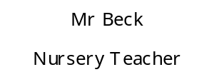

Nursery

Mrs O’Kane
Team Leader

Nursery
Miss McDonald
Early Years Worker

Nursery






Mrs Rankin
Early Years Worker

Miss Allan
Early Years Worker

Miss Campbell
Early Years Worker

Miss Evans
Early Years Worker






Mrs Haddow
Early Years Support Worker

Mrs O’Donnell
Early Years Worker

Miss Cameron
Early Years Worker

Miss Harrison
Early Years Worker





Mr Miller
Head Teacher
Miss Rennie
Acting Principal Teacher (Currently on Mat Leave)
(Currently on Mat Leave)
Miss Elliot
Acting Principal Teacher

Miss Thomson
Principal Teacher (Currently on Mat Leave)

Nursery Opening Hours

The nursery class offers a term time service. This means that we close for school In-Service days and school holidays.

Nursery Session: Doors open from 8:50am and open again from 2:50pm for children to be picked up no later than 3pm.

The nursery session is arranged as flexibly as we can in an effort to meet your needs and to accommodate as many children as possible.
If you are running late in the morning, please can you call before 9.30 to enable us to order lunch from the lunch hall.
If you are running late to collect your child from nursery, we ask that you phone the nursery prior to 3pm to inform us of this.

School Holidays & In-service days for 2026-2027
August 2026
Teachers return on Tuesday 11th August 2026
All pupils return on Thursday 13th August 2026
In-service day - all schools
11th & 12th August 2026

September 2026
September weekend
Friday 25th and Monday 28th September 2026
Pupils return on Tuesday 29th September 2026
October 2026
October break
Monday 12th to Friday 16th October 2026
Pupils return on Monday 19th October 2026
November 2026
In-service day - all schools
Monday 9th November 2026

December 2026 and January 2027
Christmas/New Year
Schools close at 2.30pm on Tuesday 22nd December 2026
Schools re-open on Wednesday 6th January 2027

February 2027
February break
Monday 15th and Tuesday 16th February 2027
In-service day - all schools
Wednesday 17th February 2027

March 2027 and April 2027
Easter Weekend
Friday 26th March (Good Friday) and 29th March 2027(Easter
Monday)
Spring break
Schools close at 2.30pm on Friday 2nd April 2027
Schools re-open on Monday 19th April 2027

May 2027
May Day
Monday 3rd May 2027
In-service day - all schools
Thursday 6th May 2027

Local holiday
Friday 28th and Monday 31st May 2027
June 2027
Summer break
Schools close at 1pm on Friday 25th June 2027

Our Aims and Vision
At Spittal Nursery Class we aim to offer the highest quality of service.
Aims:
- Provide a stimulating learning environment that is safe, rich, happy, relaxed and interesting where children will have a wonderful time and feel welcome.
- To create experiences which will promote self-esteem and allow children to become independent and confident.
- To offer a well-balanced and appropriately resourced curriculum which will enable each child to celebrate success and reach their fullest potential.
- To establish a close partnership with parents/carers, encouraging them to become partners in their child’s learning.
- To establish good relationships and foster caring attitudes where manners and respect for self and others are important.
- Continually monitor, review, and develop our service through staff development, consultation with all stakeholders and regular evaluation of resources.
Objectives:
- That opportunities are available for children to explore, investigate, be creative and use their imagination.
- That children, parents/carers and staff are made to feel valued, trusted and that their views and opinions are important.
- That children have access to a suitable resourced curriculum full of experiences and activities suited to their individual needs.
Vision:
Our vision is to provide a happy and safe environment which is stimulating, free from gender stereotyping and reflective of the multicultural society of today. We will promote self-esteem and allow children to become independent and confident whilst offering a Curriculum for Excellence.


A Typical Session at Spittal Primary Nursery Class
Parents drop off their child
Welcome & Free play
Shine Time
Healthy Snack


Free Play (Outdoors too!)
Lunch
Tooth brushing (twice per week)
Activities/Games in the Gym Hall (twice per week)
Free Play (Outdoors too!)
Tidy Up
Home Time

Security in the Nursery
Parents/carers are welcomed into the nursery to drop off and collect their child in the nursery playroom. Sign in sheets will be with your child’s keyworker to sign them in when you arrive in the morning. Due to health and safety, we ask that only 1 adult per child comes into the nursery when dropping off and collecting your child.
Clothing for Nursery
The children enjoy participating in messy play activities using paint, glue, sand, water, dough and flour. Children play outside in our nursery play area and participate in active play during the nursery session. Clothing should therefore be suited to all these activities! Children should wear soft shoes. Preferably black plimsoles that can stay in nursery. When choosing shoes for wearing to nursery please do not send your child in lace up shoes as we are always working on the children’s independence and makes it harder when they have lace up shoes.
Please make sure that your child wears clothes which are easy to remove when they go to the toilet. We aim to encourage the children to be independent so trousers with elastic waists are ideal. Please try to avoid fussy fastenings which can be unmanageable for the children such as belts, buckles, buttons, and dungarees.
If we need to change your child, we will ensure that this is as stress free as possible. We will inform you of this when you collect your child at the end of the nursery session. If your child has to be changed into spare nursery clothing, please wash and return these as soon as possible. May I remind you that South Lanarkshire Council stipulates that football colours should not be worn to nursery.

Please put your child’s name on ALL items of clothing!


Clothing for all Seasons
Outdoor activities are central to your child’s learning and development. We have a free-flow system in operation within the playroom and garden. Children are free to choose where they would like to play throughout the day. Children are required to have appropriate outdoor clothing including a waterproof jacket and suitable footwear every day to enable them to participate in outdoor play. Could you please provide a pair of wellies for your child to leave in nursery so they can use them while they are outside.



Sunscreen Protection for your Child
Outdoor learning is an important part of Curriculum for Excellence. At Spittal nursery class we are a free flow playroom and garden, so the children are able to choose when they want to play inside or outside throughout the day. During the summer months when the weather is warm and sunny, we ask that parents ensure their child’s skin is properly protected against the sun. Please apply sunscreen protection cream on your child before they come to nursery. On sunny days children should wear a sun hat to protect them from the sun.




Snack and the promotion of healthy eating
An important part of the nursery session is snack time. We aim to encourage the children to try a variety of healthy foods and offer a wide range of healthy options. Our snack includes a wide variety of fresh fruits and toast. The children drink either milk or water with their snack.


Allergies/Dietary Requirements
It is important that we are made aware of any special dietary requirements for your
child. Please let a member of our nursery team know if your child has any special requirements or food allergies.

We are happy to have a special snack on your child’s birthday. Parents/Carers, if they wish, can provide a ‘shop bought’ cake on the day of their child’s birthday. Each child will be given a small piece of cake. Spittal Nursery is a nut-free zone. In Spittal nursery class we need a form completed to state if your child cannot eat certain foods due to religious beliefs or special dietary requirements. We also require a form completed and a note from your doctor if your child has any food intolerances or allergies.



Illness, Emergency and Medication
If your child is unable to attend nursery, please telephone our direct number and leave a message prior to the start of the session.
Please ensure that you keep us informed of any changes to home details e.g. address, mobile phone numbers etc. It is important that the phone numbers given to us, for emergency use, accept incoming calls.
Medication should be administered by parents before coming to nursery. Any essential medication which may be required in an emergency e.g. inhaler, allergy medication etc. should be brought to nursery and will be stored in the first-aid cabinet. Parents will be asked to complete a medical form detailing its use and will be informed each time it is administered.

For the welfare of all our children we ask that you keep unwell children at home to avoid the spread of illness and infections. In line with NHS guidelines, children who have sickness or diarrhoea should be kept at home for 48 hours after the symptoms disappear.

If your child becomes unwell at nursery, we will phone parents or emergency contact immediately. We suggest that if your child has been sent home, they should remain there the following day also. The NHS exclusions criteria is listed on our information board but please do not hesitate to contact us if you are unsure.
It is wise to regularly check your child’s hair for head lice too. Children may attend nursery once they have been treated. Please inform staff if you have any questions or concerns about this.

Policies and Procedures
If you would like to read about the nursery policies and procedures a folder related to education and health and safety at Spittal Nursery is available in the nursery welcome area.
Curriculum for Excellence
Curriculum for Excellence is about ensuring that we help develop and educate our children to become;
Successful Learners: with enthusiasm and motivation for learning.
Confident Individuals: with emotional well-being with self-respect and ambition.
Responsible Citizens: with respect for others and effective contributors who can communicate and solve problems.
Effective Contributors: who can communicate and solve problems.
In the nursery the children learn through play and investigation. A broad and balanced curriculum is provided through a variety of topics and the children’s interests.


Health Promoting Nursery
The nursery promotes healthy eating through topics, healthy snack choices, regular physical activities, hand washing and tooth brushing.



Nursery Lunches

Nursery lunches are provided for every child; we have a nursery menu which provides a variety of choices, children can choose from 2 hot lunch options or a sandwich choice each day, a dessert, salad and fruit is also available every day. As we are a health promoting establishment, we are encouraging children to choose a nursery lunch and are kindly asking our families to work with us in minimising the number of packed lunches in nursery. Water and Milk are available throughout the day for children to access by themselves, therefore we are also kindly asking that water bottles are kept at home.


Care Inspectorate
The nursery is registered with the Care Inspectorate. We were last inspected in October 2019. A copy of this report is displayed beside the notice board.

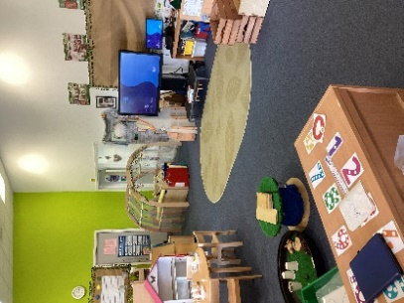
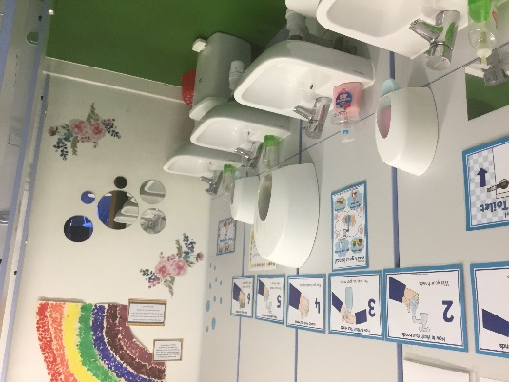
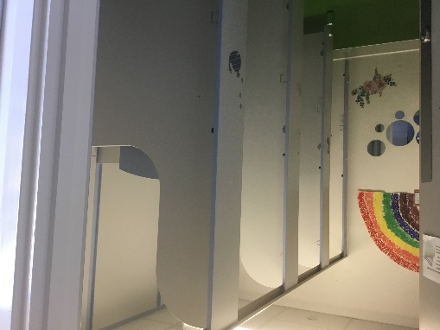
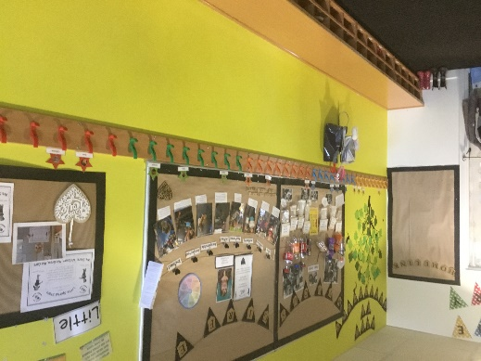
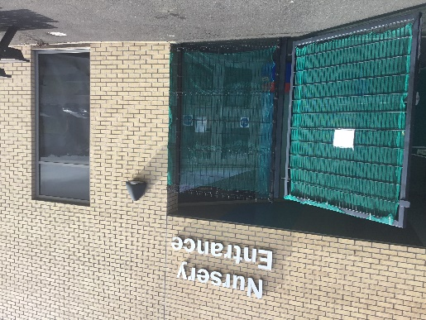
Some pictures of the nursery.
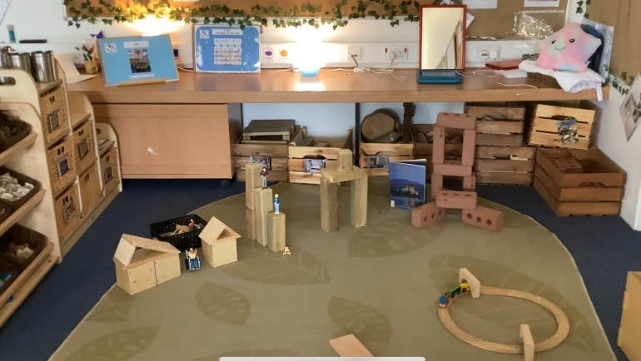
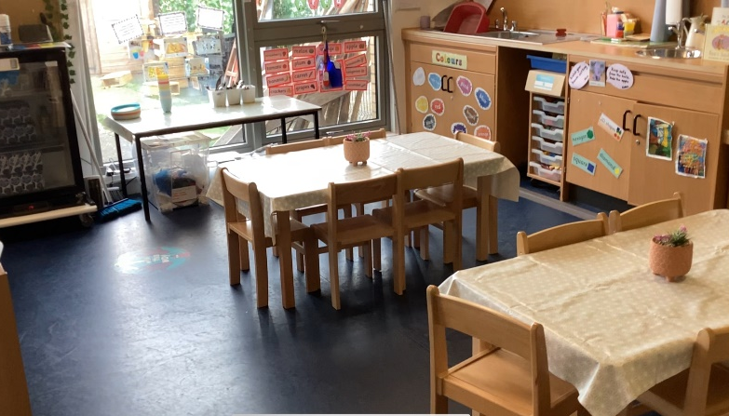
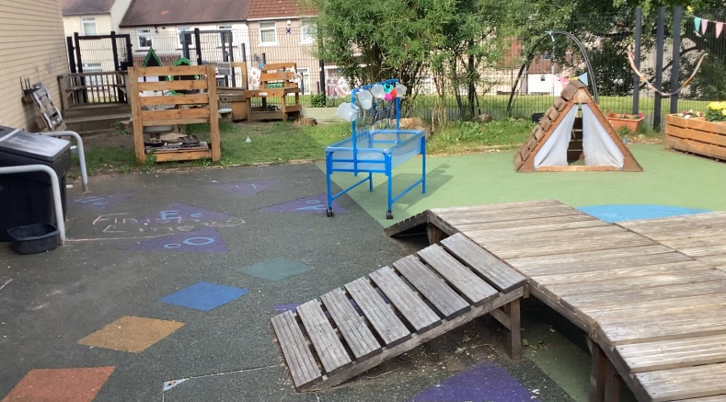
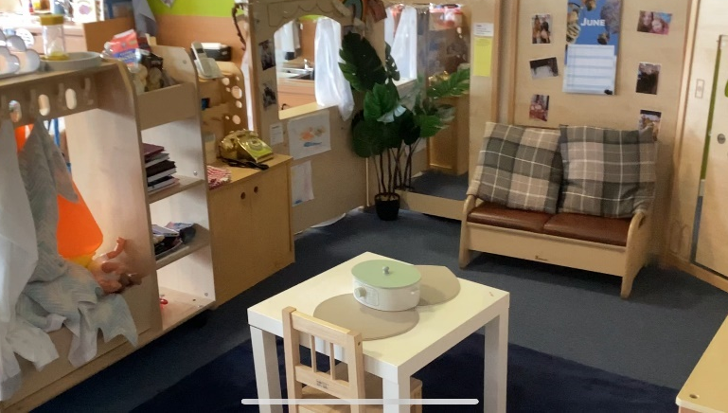
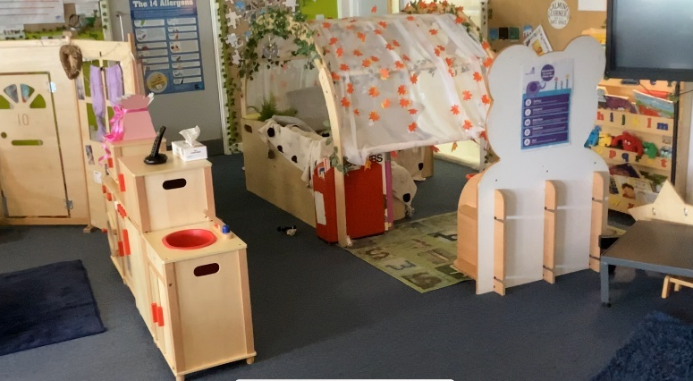
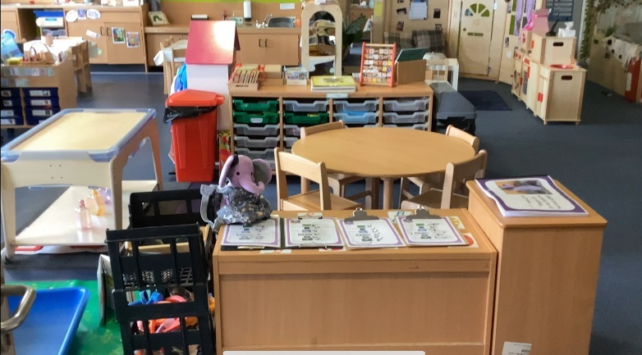
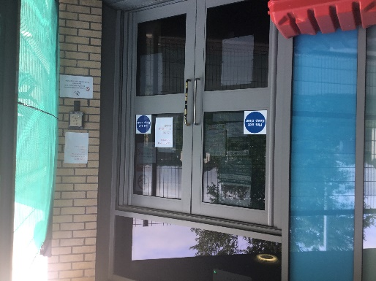
Collection of Children
It is important your child is collected from nursery on time. Children become anxious and upset when they are collected later than expected. If you are delayed for any reason, please telephone the nursery to advise us. If your child has not been collected by the end of session the following procedures will be carried out.
- Parents/Carers will be contacted.
- If there is no response, we will telephone the emergency contact.
- The head teacher will be informed.
- If we have been unable to make contact, the head teacher will contact Rutherglen Social Services Department.



Suggestions and Complaints
We hope that your child’s time at Spittal Primary Nursery Class is one you will recall with happy memories. It is important that we know how you feel about the service you and your family receive and we welcome your views. Please feel free to post any suggestions, ideas or opinions in our suggestion box situated in the nursery welcome area.
Occasionally there may be times when you wish clarification on practice and procedures or may wish to complain. If you have a complaint about any aspect of this service, please speak to a member of nursery staff who will strive to resolve your concerns. Alternatively, please speak to a member of our senior management team; Miss Thomson, Principle Teacher, Miss Rennie or Miss Elliot, Acting Principal Teachers or Mr Miller, Head Teacher. We will endeavour to deal with all complaints promptly.
If you feel that you would like the matter to be investigated further, please contact:


or Care Inspectorate Princes Gate South Lanarkshire Council Castle Street Council Offices Hamilton Almada Street Telephone: 01698 208150 Hamilton Telephone: 08457 406080

We hope that you have found the information in this booklet useful and informative. We look forward to supporting your child throughout their learning journey in
Spittal Primary Nursery Class.


