 | Spittal Primary School & Nursery Class  Stonelaw Learning Community, Rutherglen   | 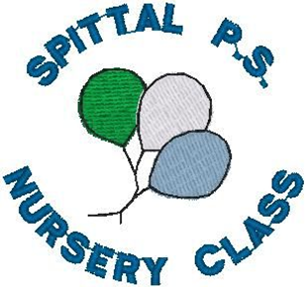
OUR IMPROVEMENT FOCUS 2026–27
A parent-friendly guide to what we are working on this year
1 CURRICULUM & SKILLS | › | 2 LEARNING & ATTAINMENT | › | 3 WELLBEING & INCLUSION

  1 | Curriculum, Skills & Play  Helping children become curious, confident learners with skills for life.  • Refresh our curriculum in line with new South Lanarkshire and national developments.  • Make skills for learning, life and work more visible; P4–P7 will begin profiling and talking about their skills and achievements.  • Build enquiry and STEM through “Big Questions”, interdisciplinary learning and our Enquiry & STEM Den.  • Develop outdoor play with OPAL and partners, creating more engaging resources and play opportunities.  • In nursery, strengthen Planning in the Moment, STEM, sustainability, children’s rights and family learning.  What families may notice: more hands-on enquiry, children talking about their skills, improved play spaces and more opportunities for nursery families to learn together.

  2 | Learning, Teaching & Attainment  Making every lesson count and helping every child make strong progress.  • Continue Improving Our Literacy, reading for pleasure and evidence-informed approaches to listening, talking, reading and writing.  • Refresh our “Gold Standard” for learning, teaching and assessment so challenge, engagement and feedback are consistent across classes.  • Strengthen numeracy through concrete materials, VCPA and Number Talks, helping pupils explain the strategies they use.  • Use tracking, moderation, learning visits, pupil/parent feedback and peer-school review to identify what is working and what needs to improve.  • In nursery, use tracking and learning journals more consistently to plan each child’s next steps.  What families may notice: clearer learning and feedback, continued reading initiatives, more maths discussion and teaching that responds closely to children’s next steps.

  3 | Wellbeing, Inclusion & Equity  Ensuring every child feels safe, included, supported and ready to learn.  • Use the CIRCLE Framework to identify and reduce barriers to learning, participation and independence.  • Strengthen nurturing, attachment-informed and trauma-sensitive approaches across school and nursery.  • Improve transitions, particularly into N4 and from N5 to P1, including home visits and enhanced support where needed.  • Continue targeted support for attendance, engagement, learning and family wellbeing with school staff and partner agencies.  • Listen to children and families so their views help shape our improvement work.  What families may notice: more consistent supports, smoother transitions, stronger family partnership and a continued focus on positive relationships, attendance and wellbeing.

HOW WILL WE KNOW IT IS WORKING?  Children can talk about their skills and achievements • strong progress in literacy and numeracy • engaging, high-quality learning • improved wellbeing, inclusion and playtime experiences. | YOUR VOICE MATTERS  Look out for family learning, Parent Council opportunities, Nursery Natter, questionnaires/consultations and pupil “Spittal Shout-Out!” activities.
We SHINE like Spittal Stars! • Safe • Happy • Inspiring • Nurturing • Excellence & Equity

