Spittal Primary School and Nursery Class
Standards and Quality Report 2022/23
Context of the school:
Our School: Spittal Primary School and Nursery Class is a non-denominational school situated in the area of Spittal in the district of Rutherglen and Cambuslang, South Lanarkshire.

The new school building opened in December 2012 and offers accessible accommodation which is designed for Education in the 21st Century, ensuring a positive learning environment for all learners.

In session 2022-23, the school had a roll of 156 pupils which was split over 7 classes. The nursery class had up to 40 children who have had the opportunity of being in nursery from 9am – 3pm each day as part of Scottish Government’s pledge for 1140 hrs Early Learning and Childcare.

Staffing consisted of the Head Teacher, 1 Principal Teacher, 7 teachers and 6.5 support staff. 5 members of support staff working throughout the school supporting various children with learning and teaching whilst we had 1.5 members of support staff offering clerical support. The nursery has a Nursery Team Leader, 0.4 peripatetic EY teacher, 6 Early Years Workers (6 FTE) and 1 Early Years Support Worker.

Spittal Primary School was awarded Pupil Equity Funding of £64,900 for session 22-23. We used some of this funding to increase our staffing allocation by increasing by 0.6 teacher and by a full time Support Assistant to allow us to focus attention on targeted groups of children to raise attainment and also to support recovery. We invested in new resources and staff training with a particular focus on Literacy, Health and Wellbeing, Outdoor Learning and Play.

In session 22-23 of our roll of 156 school pupils, 68.3% lived in a home within SIMD 1 or 2, 21.8% within SIMD 3 (91.1% SIMD 1-3), meaning only 9% of our school roll live within SIMD 4-10. 37% of our school pupils – 57 pupils were in receipt of Free School Meals, 79% of our school roll either live in SIMD 1 or 2 and/or in receipt of Free School Meals. These figures are significantly higher than SLC or national levels. 44 pupils are in the school through placing requests representing 28% of our total pupils.

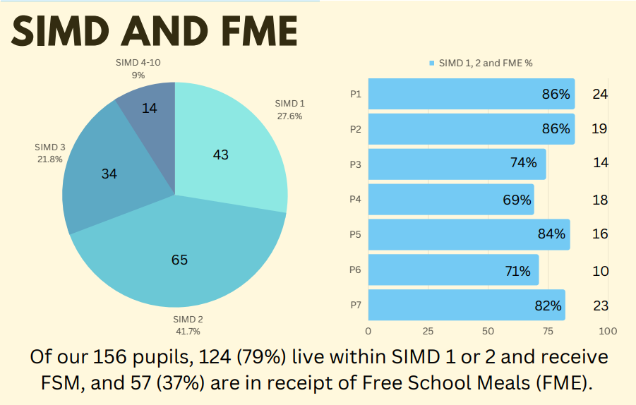

Attendance, EAL and Additional Support Needs:

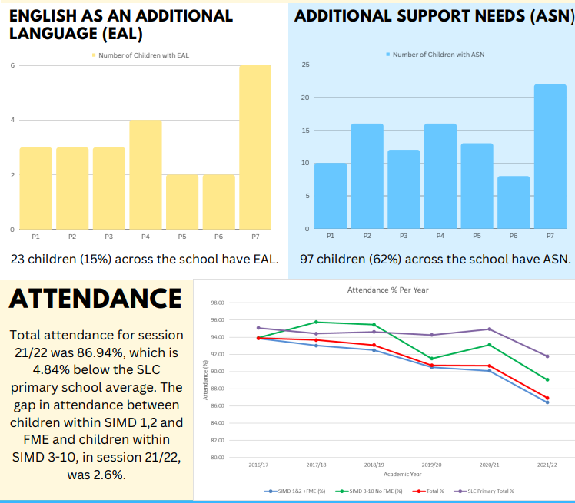

Spittal Primary has high expectations and aspirations for all its learners and the staff work effectively as a team and with partners to ensure that we provide the very best learning experiences for all of our learners which will raise attainment consistently, ensuring that our pupils develop as successful learners, confident individuals, responsible citizens, and effective communicators. We aim to nurture happy and confident children who will be successful and will contribute positively to the wider community.

Vision, Values and Aims: (currently under review)

In Spittal Primary we aim to provide a safe, positive, and welcoming environment where all members in our school community can be supported, nurtured, and encouraged to be the best they can be.

Vision Statement:
We share, we learn, we grow, we care.

Values
Supporting all learners to reach their potential
Preparing for Lifelong learning.
Including everyone in all we do
Trusting and being trusted
Teaching a curriculum for the 21st century
Aiming high to achieve success
Learning to live, living to learn.

Stonelaw Learning Community:
Spittal Primary and Nursery Class is part of the Stonelaw Learning Community and we have developed strong links to enhance transitions and extend opportunities for pupils, particularly. The school also enjoys strong partnerships with for example the Chaplaincy Team, Tesco Burnside, The Harry Heaney Day Centre, Active Schools, Operation Play (Outdoors), and Shops in/around Kyle Square. A significant part of learning & teaching involves working alongside these partners. The school is proud to hold a Silver Sports Award and is looking forward to achieving the gold award in the near future, we are also the proud owners of 5 Eco Green flags as a result of our ongoing focus on sustainability and have recently attained Silver Reading Schools status.

Review of progress for session Aug 2022- June 2023
School priority 1: Raise attainment in Literacy and Numeracy
NIF Priority (select from drop down menus)  Improvement in attainment, particularly in literacy and numeracy.  NIF Driver  Curriculum and assessment  Performance information | HGIOS?4 QIs (select from drop down menus)  2.2 Curriculum  2.3 Learning, teaching and assessment  - 1.3 Leadership of change
Strategy
What did we set out to do?

Raise attainment – Literacy

Rationale
- To improve our Writing attainment across the school with an increased focus on P3, P4 and P5.
Outcomes:
- Our ambition is to ensure attainment in writing in line with Reading, Listening and Talking and Numeracy.

- We aim to increase staff confidence in the planning, teaching, and assessment of writing through training in pedagogical approaches and also in moderation of assessment.

- We aim to raise attainment by 5% in this session and by 10% over the next 3 years.

- We aim to raise attainment in Writing across the school by 5% to 67% by June 23.

- We aim to raise attainment in the P3, P4 and P5 cohorts by 10% by June 23

- By June 23 we aim to increase attainment of levels by 10% to align with previous session averages.

Raise attainment – Numeracy and Mathematics
- To improve the pedagogy of Numeracy teaching across the whole school.
Outcomes:
- Teaching of numeracy is improved, and attainment levels are increased. This is a first step of our future focus in looking closely at our teaching methods and resources for Numeracy and Maths to ensure teachers are more aware of why they teach numeracy concepts and how they teach them.
- Increase training capacity to allow more staff to be trained on Maths Recovery – achieved through SEF funding.

Progress and Impact – 70% of SIP target achieved

What difference did we see? What did we achieve?

Writing:
- Writing attainment rose from 67% to 78% (surpassing the 5% target to 11% and achieving the 10% target over 3 years – in 1 year).
- Existing trained staff received refresher training on Talk for Writing (T4W) to ensure writing will be a focus for all teachers.
- New staff, staff not previously trained and staff that had since changed class/stage attended SLC T4W training sessions. This means all staff and SLT are now fully trained in T4W across the school.
- Planned HT observations were undertaken with appropriate feedback – it is evident that the teaching of writing is now using a more consistent pedagogical approach. This feedback was supported through learner conversation comments stating that children particularly enjoyed and responded to the Story map approach to recounting story writing and planning.
- Class teachers all analysed existing writing data to identify at least 2 pupils who are requiring input – these children were then ‘tracked’ more meticulously to ensure growth with 87% attaining the next planned level to attain ‘on track’ with their peers in their class/cohort.
- Ideas for ‘writing at home’ were shared through ‘fortnightly’ home learning grids, giving parents/carers opportunities to work alongside their child to develop their writing.
- All staff were trained by SLC Development Officer on Read&Write toolbar (assistive technology) to develop writing for children with specific learning needs but within a whole-class setting to normalise the use of ICT within writing; Development Officer then completed specific and responsive training to P5-7 classes and offered staff CLPL sessions. Staff then carried out a programme of work to upskill all children, with focus on specific learners who have since reported an increase in independence and confidence when writing. Spittal PS were chosen to be included in Spotlighting Read&Write assistive tools used across SLC as a case-study of progress and its impact on our learner’s attainment and experience.

Numeracy and Mathematics:
- All teaching staff (excl. SLT) received training in Maths Recovery pedagogy – with enhanced knowledge of the principles and practices of Maths Recovery.
- Maths Recovery resources purchased to ensure all classes have access to resource boxes and manuals (shared with stage partner).

Next Step(s) to inform SIP for 2023/2024:

- Staff continue to embed T4W approaches within weekly/daily writing.
- Peer visits to be carried out in the next session to develop teacher’s own practice through learning from/sharing with others.
- Teacher group to be set up to develop a Spittal specific approach to assessing writing – moving away from the Scottish Criterion Scale and revisit writing benchmarks to support assessment and moderation.
- Parent Workshops/Showcases: parents will be invited into class to write with their child.
- Progressive writing planners to incorporate T4W approaches (Year 3 of SIP cycle).
- Moderation (8 hours) in session 2023-24 protected time in WTA to develop teacher professional judgement and consistency in assessment (working in partnership with Burnside PS).
- Professional judgements in Writing supported by level trackers incorporated into class Cohort spreadsheets.
- Numeracy and Mathematics to be included on 3-year SIP cycle (year 1) to develop the pedagogical approach to Numeracy and Mathematics from Nursery to P7.
School priority 2: Develop further opportunities for Outdoor Learning
NIF Priority (select from drop down menus)  Improvement in children and young people’s health and wellbeing  NIF Driver  School and ELC improvement  Parental engagement | HGIOS?4 QIs (select from drop down menus)  1.1 Self-evaluation for self-improvement  2.7 Partnerships  2.2 Curriculum
Strategy
What did we set out to do?

Rationale:
- Research has shown that Outdoor Learning is beneficial to all children. Outdoor learning improves child development, supports mental health and wellbeing, deepens nature connection, and promotes more inclusive and engaging learning.
- Self-evaluation and Professional dialogue has identified that Outdoor Learning is an area that as a school we would like to develop, do more of, and children have highlighted that they are keen to take their learning outdoors.

Outcomes:
- The garden area will be further developed to allow easy access for classes in order to allow children to learn new skills, have fun, play, and develop self-confidence by spending time in the garden tending plants and growing their own food.
- This will give children a sense of ownership and encourage them to look after and respect the school grounds.
- An outdoor Reading area and Outdoor Library will be established to take storytelling and reading outdoors during class and play times.
- Staff will become more confident in planning and delivering Outdoor Learning.

Progress and Impact - 85% of SIP target achieved

What difference did we see? What did we achieve?

- Continuation of Outdoor Learning Working Party – creating its own improvement plan – including meeting agenda, minutes and resulting actions – 6 x 1.5 hours meetings over the session to develop the following:
- Water tap close to garden area to be installed to increase ability to take learning outdoors and develop the garden area.
- Competition for children/ classes to design the garden area – this was designed and implemented, with children painting planters, creating a path, making bug hotels and planting trees.
- Development of the Garden area started - working with Operation Play Outdoors, Grow 73, parents, other partners, and children to develop the garden area.
- Procurement of additional outdoor clothing/ footwear for pupils and resources for outdoor play.
- Classes shared learning with other classes and with parents e.g., news stories on App, Termly Times etc…
- A Reading circle of logs created to develop an outdoor classroom space. A selection of books made available to encourage class teachers to take reading outdoors and also to encourage children to read outdoors at play and lunch times.
- Staff CLPL delivered by Operation Play Outdoors to support teachers in what to teach and how to facilitate outdoor learning.
- Operation Play outdoors worked with all classes and staff to deliver training to upskill/increase staff capacity in leading Outdoor Learning.
- Outdoor Learning week to incorporate Loose Parts Trailer; developed and implemented – including opportunities for children to engage with Outdoor learning activities, the trailer but also developed staff own CLPL across the school. Staff and pupil feedback was positive.
- Willow Tunnel Building to create addition interest spaces within the playground.
- Outdoor Learning and Play Sessions x 6 for each class, over six-week period, led by Operation Play Outdoors.
- Professional Reading materials available in Staff Library e.g., “Educating Outdoors,” Teaching Outdoors Creatively” etc…
- EAL child participated in Forest Schools programme with children across other school in the Cambuslang-Rutherglen area.
- Outdoor Learning Google Classroom created and shared with all staff – with access to resources, meeting agendas, minutes, and actions complete/outstanding.
- King’s Coronation Garden Party launches with parental involvement (in partnership with Operation Play Outdoors) – activities included: marshmallow toasting, sport activities, outdoor cooking, orienteering, fundraising stalls etc… hugely successful with £600 raised and excellent feedback from families, staff, and children.

Next Step(s) to inform SIP for 2023/2024:

- Form 2nd year cycle within curriculum section of new SQIP.
- Create bug houses/hotels/city in/across the school grounds.
- Develop Gardening Club in partnership with Grow 73.
- Develop appropriate storage means for Outdoor Learning resources, equipment, and clothing.
- Outdoor Learning spaces to be timetabled to encourage and develop use of the space.
- Continue Outdoor Learning Week next year coinciding with Outdoor Classroom Day / One Planet Picnic Day.

School priority 3: Further develop Play-Based learning (PBL) Primary 1 and 2.
NIF Priority (select from drop down menus)  Improvement in attainment, particularly in literacy and numeracy.  NIF Driver  School and ELC improvement  Teacher professionalism | HGIOS?4 QIs (select from drop down menus)  3.2 Raising attainment and achievement  1.2 Leadership of learning  2.2 Curriculum
Strategy
What did we set out to do?

Rationale:
- Further develop Play Based Learning (PBL) within Spittal Primary and Nursery Class.
Outcomes:
- The learning environments in P1 and P1/2 will be more appropriate to PBL.
- PBL opportunities will be extended to all classes P3-P7.
- Share/develop play pedagogy knowledge and practise.
- Trial play using the 3 zones approach in Room 1 and Room 2, with one shared zone.
- Complete organisation of all resources, including labelling.
Progress and Impact – 78% of SIP target achieved

What difference did we see? What did we achieve?

- Continuation of Play Working Party – 6 x 1.5-hour meetings held throughout the year, with Action Plan created and reviewed.
- Use of observations to inform planning alongside stage partners.
- Building up bank of resources and accessible storage, through donations where possible, and purchases thereafter.
- P1 and P1/2 classrooms were rearranged to provide a more suitable environment to encourage PBL.
- Wall displays in P1, and nursery changed to hessian paper, to ensure they are more neutral and natural. Some boards changed to allow for all children to choose a piece of work they would like to display.
- Resources were organised, stored, and labelled with text/images to ensure easy access for all children, in the nursery, P1 and P1/2 classrooms as well as the playroom.
- Playroom set up into zones, with all resources organised, labelled and easily accessible. Timetable created for infant classes and nursery to access regularly.
- Free flow play implemented between P1 and P1/2 through shared play area in open area outside classrooms.
- Nursery, P1 and P1/2 consider planning and completing IDL lessons together, using PBL as main pedagogical approach. Successful with Fairyland topic, including a parent showcase.
- P1 and P1/2 teachers being mindful of PBL when planning, especially in literacy and numeracy, to ensure appropriate activities/opportunities to support learning.
- P1 teacher previously trained in PBL through SLC Play Pedagogy course and working in partnership with P2/3 teacher who was trained this year. Professional dialogue around making PBL work for Spittal’s context.
- PBL trained staff are part of professional networks in learning community, which have organised discussion, visits and sharing of best practice across local schools.

Next Step(s) to inform SIP for 2023/2024:

- Form maintenance section of new SIP and/or include in Curriculum section of 2023-24 SQIP:
- Continue to ensure P1-3 classrooms are set up with PBL in mind and consider this in upper classrooms when planning layout. This includes display boards as hessian/natural appearance.
- Create a Play Policy to ensure consistency in practice across the school and learning community.
- Try Play Based/Skills Focused lessons in P3-7, by discussing with other schools have already implemented this.
- Continue to build, organise, and store indoor play resources efficiently, while also building up bank of loose parts play resources for use outside, in line with development of garden/outdoor learning.

School priority 4: Improve Pupil Attendance and Punctuality Rates (Stonelaw LC Priority 1)
NIF Priority (select from drop down menus)  Closing the attainment gap between the most and least disadvantaged children and young people  NIF Driver  Performance information  School leadership | HGIOS?4 QIs (select from drop down menus)  1.5 Management of resources to promote equity  2.1 Safeguarding and child protection  3.1 Ensuring wellbeing, equality and inclusion
Strategy
What did we set out to do?

Rationale:
- Improve pupil attendance and punctuality rates. Research has shown a clear link between attendance and attainment.
- Children with higher attendance rates are more likely to achieve the appropriate CfE level.
- Decline since Covid-19, previously 92.42% but session 21-22 ended as 86.94%.
Outcomes:
- Increase attendance to pre-Covid level of 94% by June 2023.
- Reduce the poverty related attendance gap from 2.6% to 2.0% in session 22-23.
Progress and Impact

What difference did we see? What did we achieve?

- Improved attendance rate now at 90% for session 22-23, therefore an increase of 3% from session 21-22.
- Reduced poverty related attendance gap from 2.6% to 1.5% (exceeding the target of 2%).
- Arranged various extra-curricular clubs before school starts. Similar to the breakfast club, these were useful to encourage more children to be in school on time.
- Created improved bank of attendance letters to be sent by SLT to ensure they are supportive and building positive relationships rather than threatening/relationship-disruptive.
- Discussions with LC Head Teachers on best practice and feedback from schools based on their involvement in the Test for Change pilot.
- Continued to offer a range of Health and Wellbeing groups (e.g., ‘Nurture,’ ‘Wee Worries,’ ‘Give Us A Break,’ ‘Girl’s Social Group’, ‘P7 Transition Group’, CUSTTAD, Drawing and Talking sessions etc…) – there was an expansion to the regular programmes this year with 5 times the norm being offered.
- Improved Tracking and Monitoring system created by Head Teacher.
- SLT attended a ‘Spotlight on Attendance’ West Partnership RIC session, engaging in professional dialogue/discussion with primary and secondary colleague senior leadership teams on best practice.
- SLT tracked frequent families that were late to school and targeted our new Barnardo’s Worker to work with these families in term 3, with parental engagement having specific improvement in attendance and reduced late coming.

Next Step(s) to inform SIP for 2023/2024:

- Continue to monitor as per regular Attendance monitoring.
- Register Phase 2 ‘Test for Change’ pilot on Attendance with Equity Team.
- Create Individual Attendance Plan for selected families.
- Continue to target selected families and support with Barnardo’s Worker, improved tracking and monitoring, consistency in letters to be supportive (offer praise, where noted).

School priority 5: Improve Health and Wellbeing (Stonelaw LC Priority 2)
NIF Priority (select from drop down menus)  Improvement in children and young people’s health and wellbeing  NIF Driver  School and ELC improvement  School leadership | HGIOS?4 QIs (select from drop down menus)  1.3 Leadership of change  2.1 Safeguarding and child protection  3.1 Ensuring wellbeing, equality and inclusion
Strategy
What did we set out to do?

Rationale:
- It is recognised that post-Covid our pupils’ health and wellbeing needs are becoming more of a priority and many more pupils and parents require more support with their distressed behaviours and social and emotional wellbeing.
- Learners are not making expected progress because they are not ready to learn because of health and wellbeing barriers.
Outcomes:
- Identified pupils will continue to have improved levels of wellbeing – (identified and evaluated against internal Health & Wellbeing referral form/Boxall Profiles).
- Our whole school will continue to have a positive, nurturing and supportive ethos and practice which promotes a positive health and wellbeing ethos (identified through stakeholder SHANARRI wheel evaluation)
- By June 2023, all staff will feel better equipped with a wider knowledge and range of resources to go to for support for themselves and pupils (Identified through Attachment Audit & Plan)
- By June 2023, All Staff feel supported to de-escalate distressed behaviour through consistent approaches.
Progress and Impact

What difference did we see? What did we achieve?
- School identified an Attachment Lead/Ambassador Teacher who attended sessions throughout the 2022-23 year.
- CAT night and Inset training- stages across LC get together to discuss current practice and problems/solutions. Each school shared specific interventions we currently have in place in relation to PPRUDB/HWB/Attachment across the LC via MS Teams.
- Identified next steps for ‘Attachment’ based practice based on Inservice training from Education Psychology team.
- Shared attachment-based practice with all stakeholders e.g. A-Z of Attachment.
- All classes utilise JIGSAW, Health Scotland, Do-Be Mindful, ICE Pack and Emotion Works resources to underpin emotional wellbeing ethos and lessons.
- Implement termly SHANARRI wheel and Leuven Scale self-evaluation to continually monitor pupils’ wellbeing.
- Glasgow Motivation and Wellbeing Profile (GMWP) training for all staff and completed / analysed March 2023. This will be used for the starting benchmark for session 23-24.

Next Step(s) to inform SIP for 2023/2024:

- Continue to pursue as year 2 on SQIP next year (LC Priority ongoing).
- Introduce (formally) UNCRC: Rights of the Child either as UNICEF / Making Rights Real training.
- Streamline Health and Wellbeing Programme of Study for session 23-24.
- Continue with Attachment Ambassador Network.
- Complete, analyse and compare GMWP in Sept/Oct 23 with March 23 and take necessary action/steps – including interventions/supports.
- Create greater opportunities for recognition of achievement and reward (at class and whole-school level).
- Involvement at LC level to develop the capacity of staff to support the wellbeing of pupils and families through e.g., SAMH, Counselling for Schools, Attachment, Trauma Informed Practice, etc…

School priority 6: Nursery Improvement Plan 2022-23
NIF Priority (select from drop down menus)  Improvement in attainment, particularly in literacy and numeracy.  NIF Driver  School and ELC leadership  Teacher professionalism | HGIOS?4 QIs (select from drop down menus)  1.3 Leadership of change  1.5 Management of resources to promote equity  2.3 Learning, teaching and assessment
Strategy
What did we set out to do?

Improvement Priorities (Key Actions):
- Adapt planning to incorporate current good practice.
- Enhance and freely use outdoor area to: develop resources and make better use of space, include risky play, involving balancing, climbing, and travelling on different surfaces and levels.
- Enhance the Lending Library programme to include story sacks and incorporate family workshops to enhance literacy skills.
- Develop digital skills by ensuring digital literacy and digital technology is planned for, resourced, and included in daily activities.
Progress and Impact

What difference did we see? What did we achieve?
- Adopted ‘Planning in the Moment (PiM)’ and trialled this with the support of a peripatetic EY Teacher.
- Evaluated, reviewed, and adapted PiM following consultation with all staff.
- Feedback given to staff in partnership with EY Peripatetic Teacher and EY Team Leader.
- Children now have free-movement to the outdoor area – all day, every day.
- Purchased additional resources such as the Shed ‘Cosy Cabin,’ climbing frame and planters to develop the outdoor space.
- Further enhanced block play outdoors and developed greater creative opportunities through loose parts play outdoors also.
- Lending Library reinstated
- Cosy Cabin used to develop reading space for nursery children.
- EYW created home-links session for Billy Goats Gruff.
- Newly purchased child-friendly digital camera, bee bots and 5 iPads for child use. Smartboard replaced and children have planned-for experienced and regular access to digital technologies all day, every day.
Next Step(s) to inform SIP for 2023/2024:

- Continue to review and implement PiM planning approach.
- Develop a nursery and whole school aligned Quality Assurance approach and incorporate this into a Yearly Calendar overview
- Continue to develop ‘Risky Play’ / ‘Forest Schools’ methodology/pedagogy.
- Create more opportunities for building community through Family Support/Family Learning programmes/workshops etc…

National priority: How we are ensuring Excellence and Equity?

Strategy

Brief commentary on context and identified barriers to learning which affect progress and attainment, key interventions undertaken

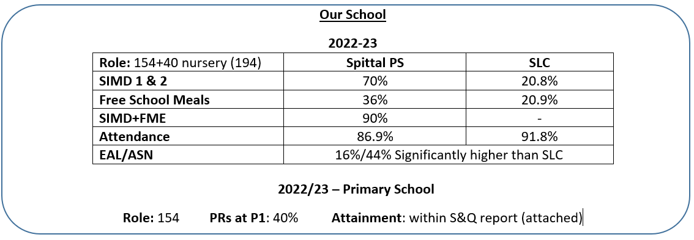

Key Interventions:

- Nurture (3 groups, 1 hour each day, 5 days a week)
- 5-Minute Box (Lit and Numeracy)
- IDL (Literacy and Numeracy)
- Catch Up (Literacy)
- Catch Up (Numeracy) – (training undertaken this session)
- Drawing and Talking (training undertaken this session)
- Maths Recovery (training undertaken)
- WordShark
- NumberShark
- Lego Build to Express
- Recovery/Support for Learning Teachers / School Support Assistant
- Check-ins/Girls-HWB group/ Transition groups.

Progress and Impact (see next page):

What difference did we see? What did we achieve?
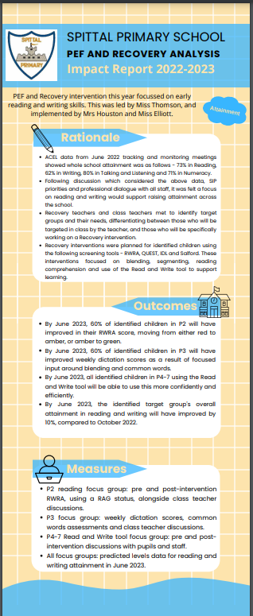
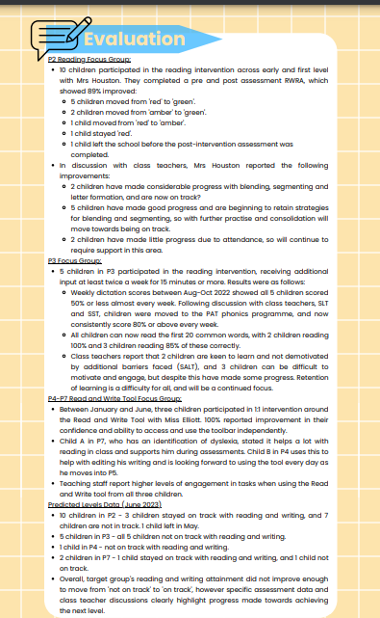
Next Step(s) to inform SQIP/PEF Plan for 2023/2024 (see below):

